1 ) create a design in html5 and css3 using Flex

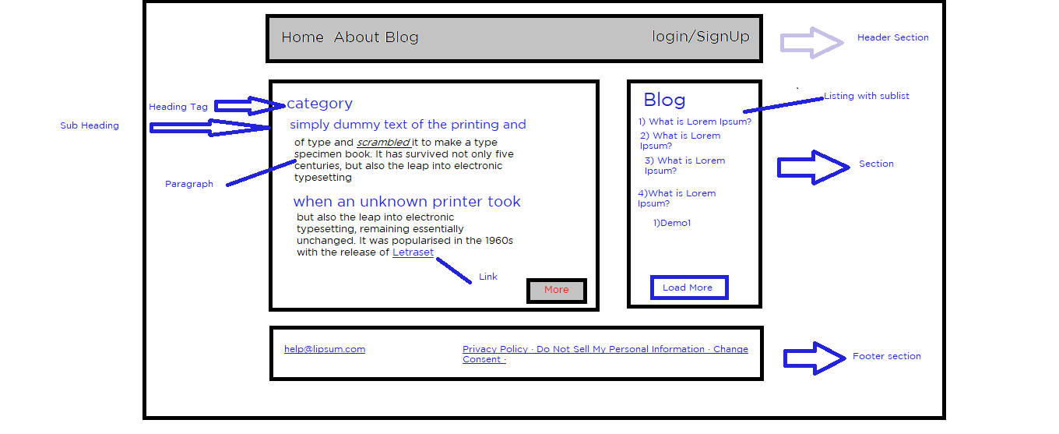

2) JQuery   
output =>

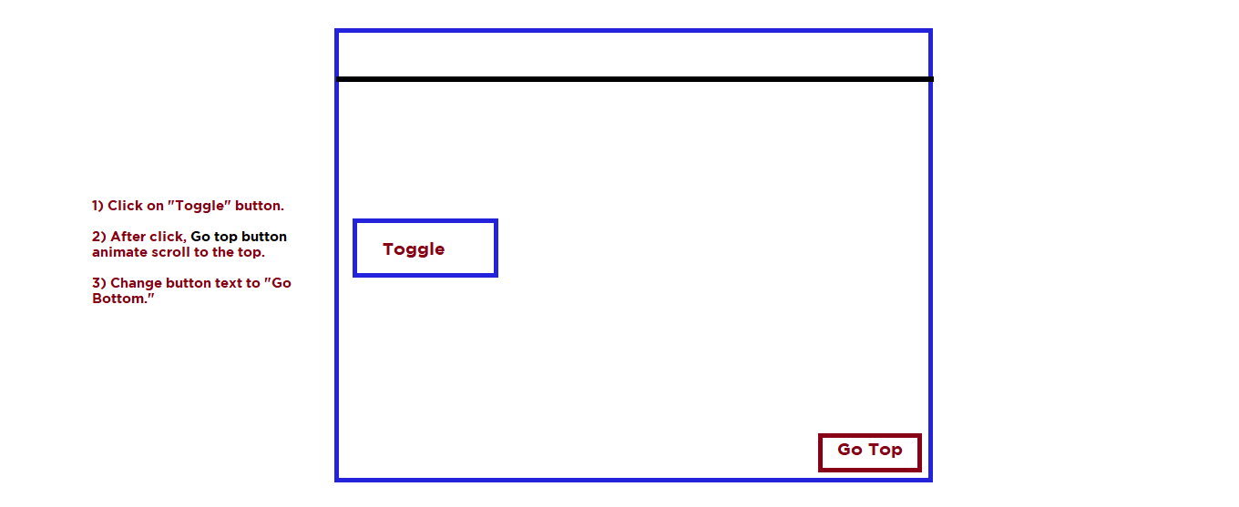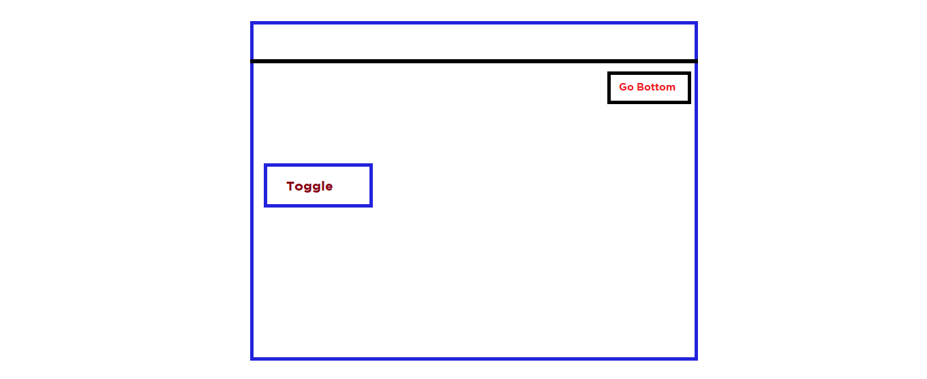

3) JavaScript

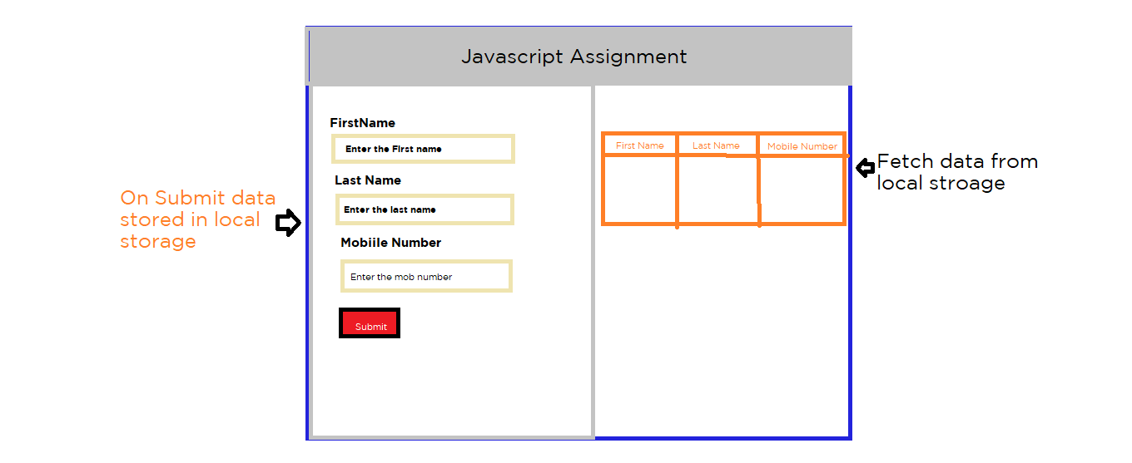

4) React / Node /Express

Component =>

Header component , Login component , add user component, Add dialog open in same page after adding the information page redirecting to listing component.

1) Header should be only one

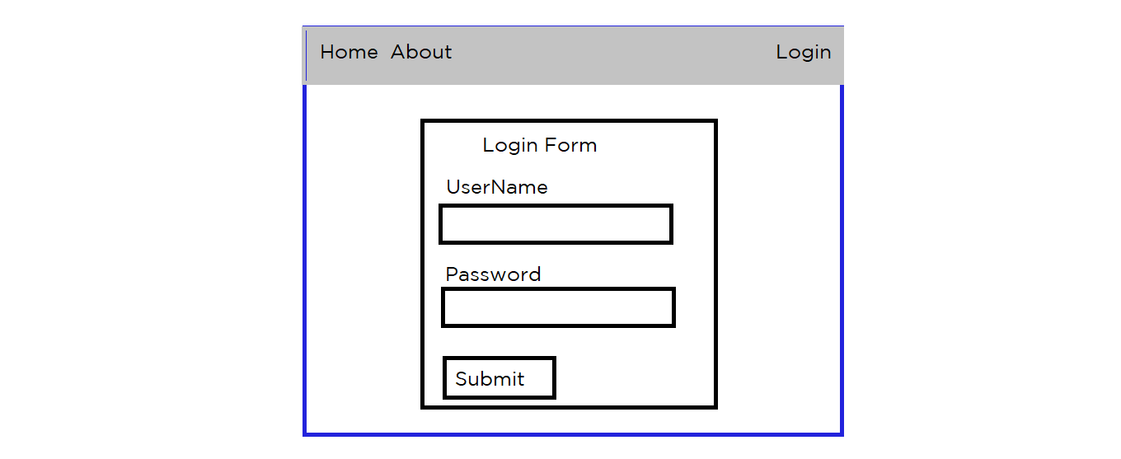

After login with demo details=>

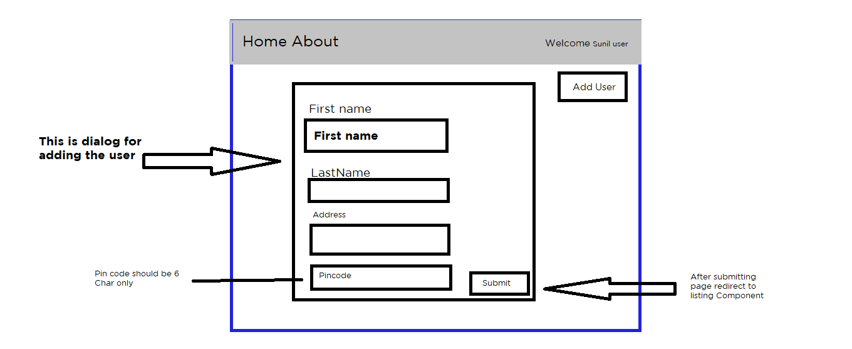

edit the information also delete the information

